Wallarm Filtering Node Summary

Step1;

## Set Up FastAPI Backend

1. I opened VSCode and create a project folder:  
 mkdir wallarm-fastapi-demo && cd wallarm-fastapi-demo && code .  
  
2. Create the backend app in 'src/main.py':  
 from fastapi import FastAPI  
 app = FastAPI()  
  
 @app.get('/demo')  
 async def root():  
 return {'message': 'Hello from FastAPI backend!'}  
  
3. Add requirements.txt with fastapi and uvicorn  
4. Add Dockerfile to build the app using Python 3.10

Step 2

Create a docker-compose.yml file in the root folder.  
2. Define services for Wallarm WAF and FastAPI backend.  
3. I set environment variables including your WALLARM_API_TOKEN, from the wallarm documentation  
4. Run 'docker-compose up --build' to deploy both services.

Step 3

1. Run this code to simulate the attacks - docker run --rm -v ./reports:/app/reports --network wallarm-demo_wallarm-net -it wallarm/gotestwaf --url=http://wallarm-svc:80/demo --blockStatusCodes 200

2. Verify output for blocked attacks through the Wallarm cloud platform and compare with the report.

Results

This shows the FASTAPI is sending the requests through to the Wallarm Platform.

**This is the GoTestWaf container**:

docker run --rm -v ./reports:/app/reports --network wallarm-demo_wallarm-net -it wallarm/gotestwaf --url=http://wallarm-svc:80/demo --blockStatusCodes 200

The node flagged 97 attacks in monitor mode in GoTestWaf attacks.

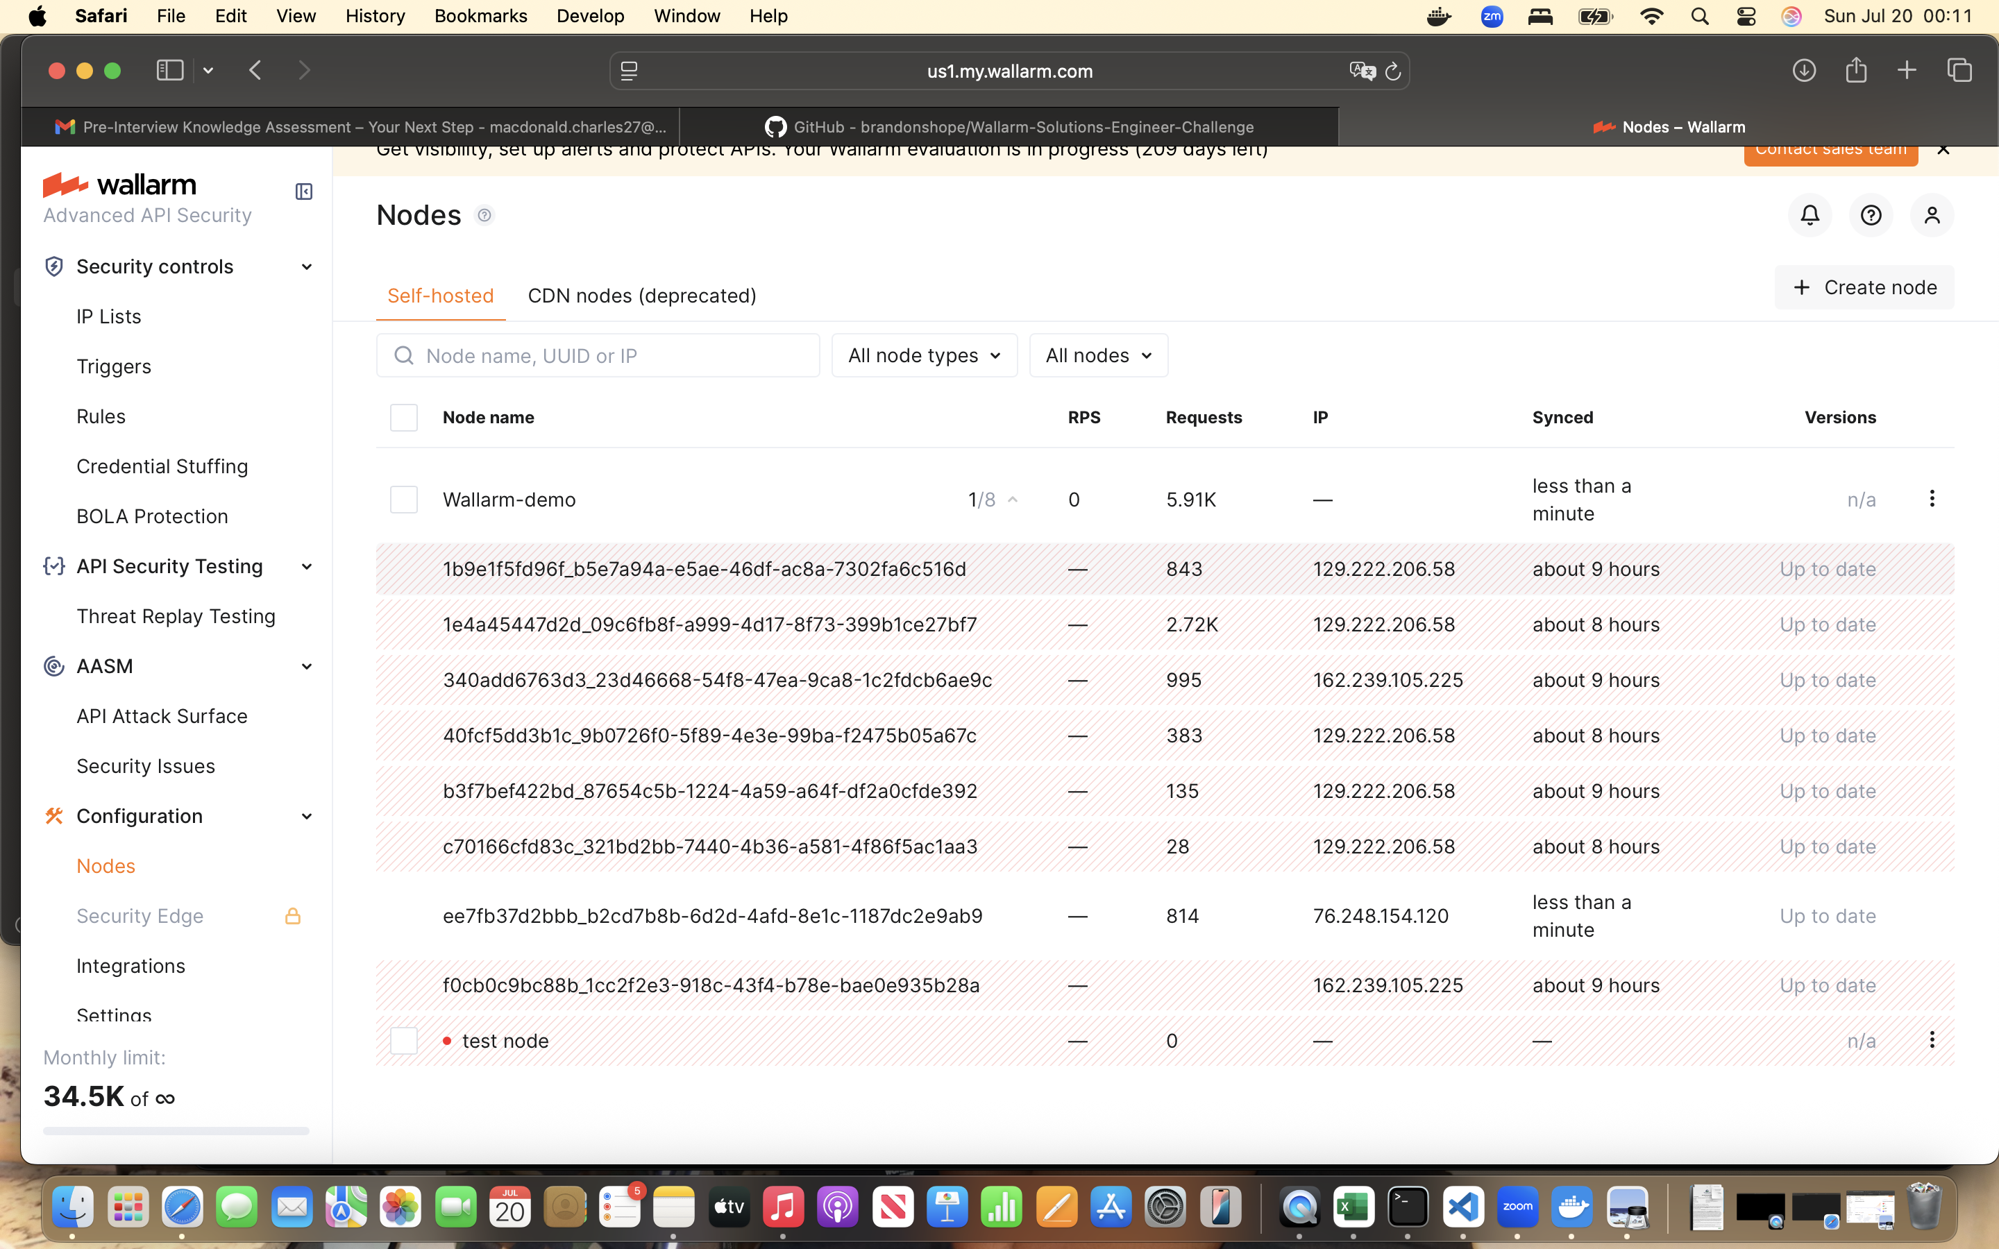

This shows that the token used in the Wallarm cloud platftorm is working.

This shows the container was created and it ran successfully and was in an container in docker( the chosen deployment is docker)

I have attached the pdf generated and this will show the results but here is a snapshot of the results. Which shows the initial 108 requests that went through the node, soon after that the 708 requests didn’t go through. What I think is the reason the WAF is not handling all attack categories- which may require specific policies to be enable in the Wallarm UI. I am certain the traffic is being routed correctly through to Wallarm because I fixed the traffic is going through the correct port.